

Hah hah haa!!

**Bullying in school**

**Tommy, Santeri, Milja and Pilvi**

It’s morning and Sofia is going to school.



I can’t focus…

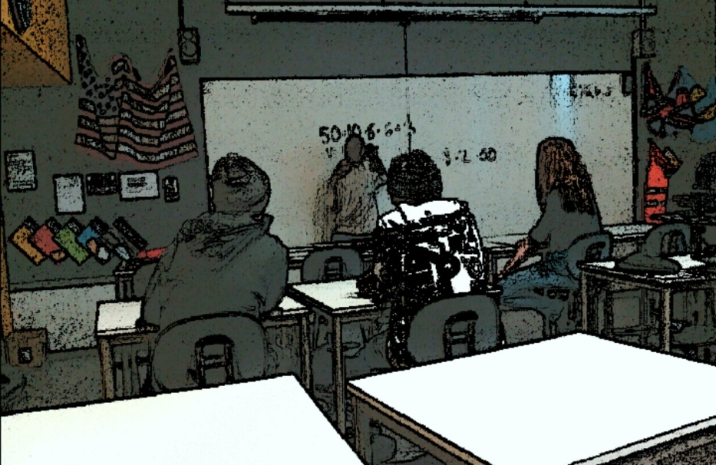

In the class…

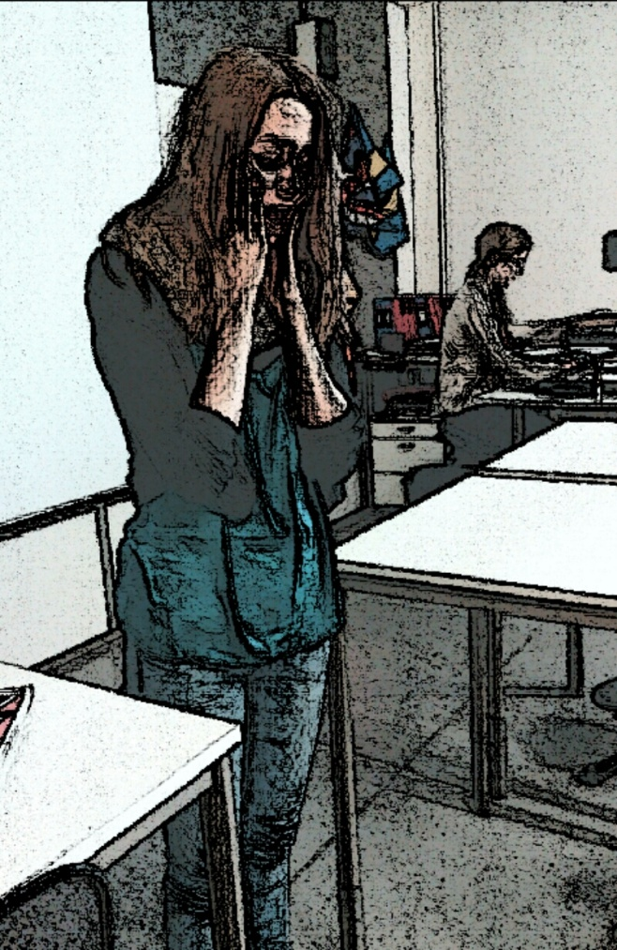 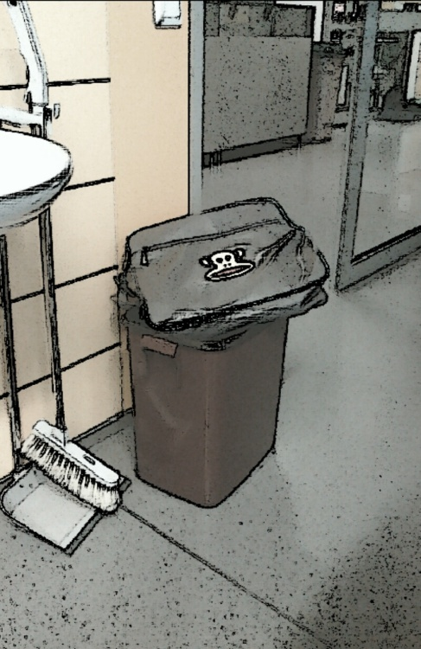 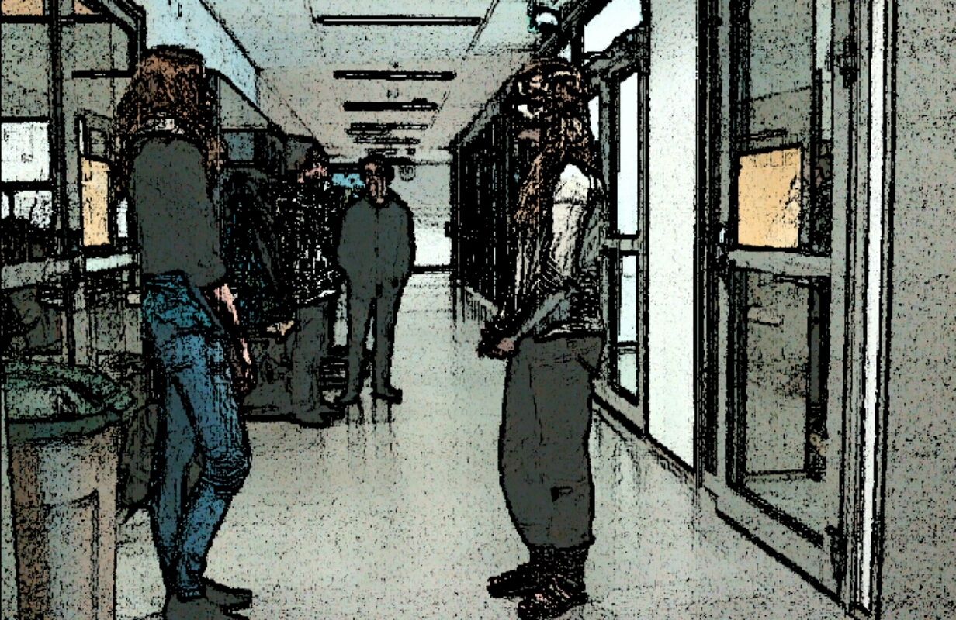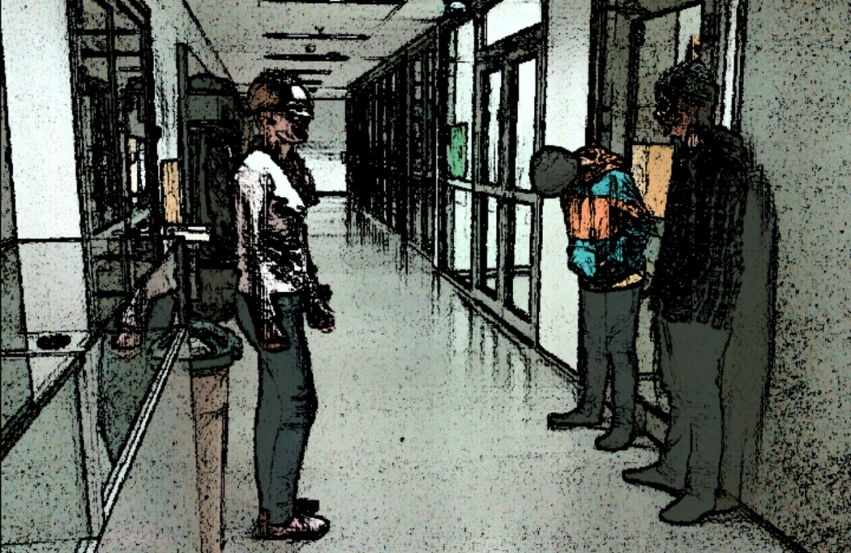

Those boys are bullying me. Can you do something for it?

My bag is lost!

Okay. I will talk to them.

We will never stop doing that!

Boys, you need to stop doing that.

I don’t think so…

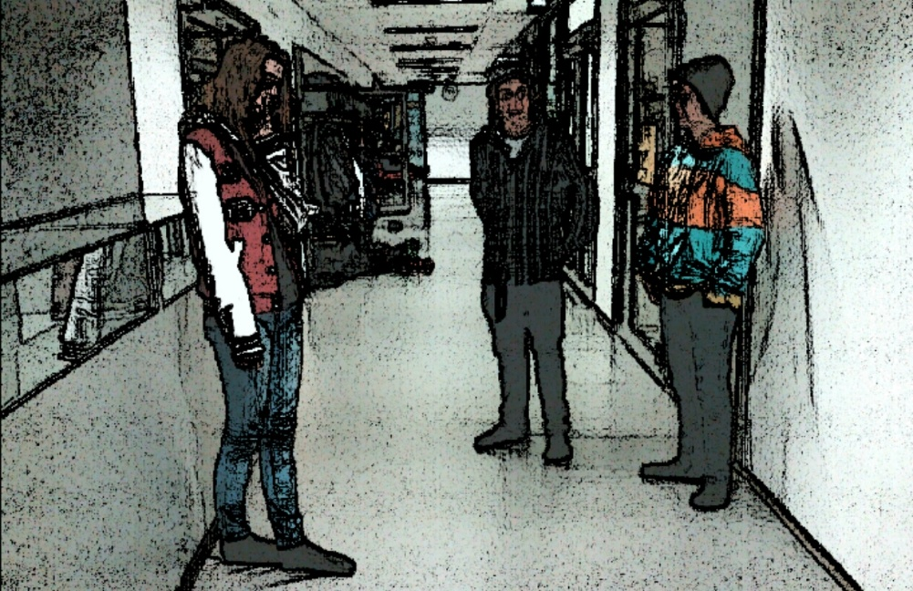

I can’t take this anymore!

She had to move to other city and school.